MINISTRY OF SCIENCE AND EDUCATION NATIONAL TECHNICAL UNIVERSITY “KHARKIV POLYTECHNIC INSTITUTE”

DEPARTMENT OF SOFTWARE ENGINEERING AND MANAGEMENT INFORMATION TECHNOLOGIES

Report from lab#8

Discipline “Software Architecture ”

Executed by: Student of group 1.КН201.8ei1

CHUKWU IRELE AMORIN

Checked by:

Prof. Khtasko

Task : Deployment Diagram

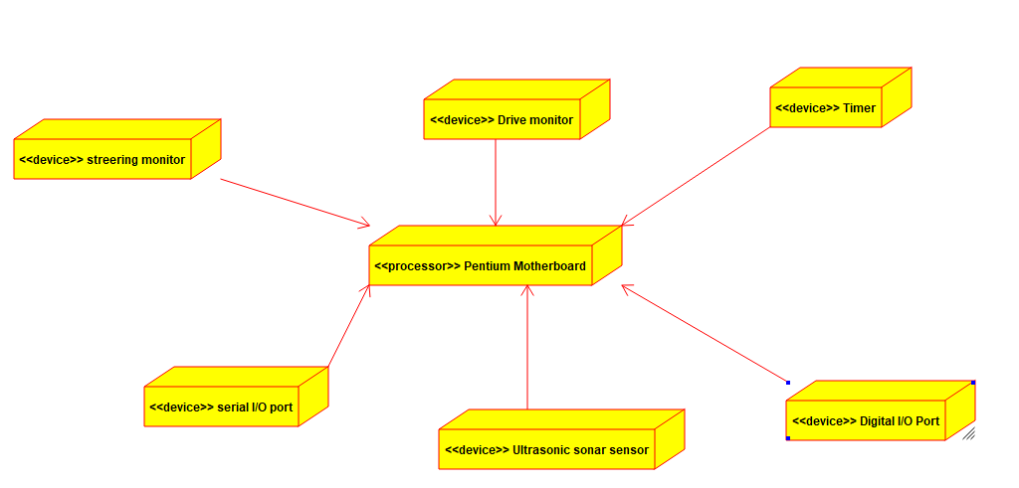

Mother board System : this a deployment diagram that show the deployment of various device to make up the mother processor function .The addition of each device is make up the whole processor .